**Project Design**

**Phase-I Solution**

**Architecture**

| Date | 24 September 2022 |
| --- | --- |
| Team ID | PNT2022TMID24400 |
| Project Name | Personal Assistant for senior people who are self-reliant |
| Maximum Marks | 4 Marks |

**Solution Architecture:**

• Old people who are in need of pill reminder and self-assistance because they don't want to skip their medicines.

• Create a web application which reminds the tablet name and time & Create a smart watch which rings an alarm and vibrates on time.

• It reminds the medication time through alarm and vibrations. **Solution Architecture Diagram:**

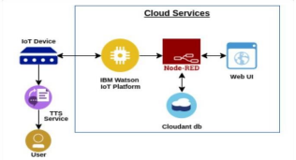

Health Report 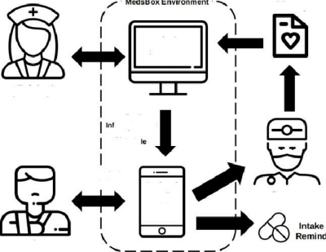

Admin

System

Clinician/

Pharmacist

Medication

or mation and

A pp oi nt:ment

Schedu

Set Prescription

RemindgE Patient

Doctor

Medicine

Patient

Guardian Mobile Phone'